

Statement of Work
  - SOW 03/12/2026

Table of Contents
Background & Context 3
Engagement Objectives 3
Scope of Work 4
Out of Scope 7
Assumptions & Client Dependencies 7
Dependencies & Prerequisites 7
Risk Management Approach 8
Tentative Timelines 9
PROJECT DELIVERABLES & ACCEPTANCE CRITERIA 9
SUPPORT & WARRANTY 10
Cost Estimates 11
Invoicing 12
CONTACT INFORMATION 13
Confidentiality & Ownership 13
Acceptance & Sign-Off 14

STATEMENT OF WORK
This Statement of Work (“SOW”) is between Compass Group (“Compass”) and Damco Solutions Inc. (“Damco”), is effective as of March 2, 2026 (the “Effective Date”).
Subject to the terms of this Statement of Work, Client and Damco agree to following:

Background & Context
The current Cashroom verification process is maintained manually through Excel spreadsheets across multiple locations. This manual process presents several challenges including limited visibility, inconsistent data quality, lack of real-time compliance monitoring, manual approval workflows, and difficulty in generating audit-ready reports.
Daily Cashroom operators struggle with complex Excel formulas, leading to data entry errors and compliance gaps. Finance and audit teams face challenges in consolidating data from multiple locations and identifying variance exceptions in a timely manner. The approval process relies on email exchanges and lacks proper audit trails.
This Statement of Work proposes a comprehensive AWS-native digital solution to transform the Cashroom compliance process, making it more efficient, accurate, and audit-ready while maintaining the highest standards of security and data integrity

Engagement Objectives
The primary objective of this engagement is to design, develop, and deploy a cloud-native Cashroom Compliance System that digitizes and streamlines the daily Cashroom verification process across all locations.

Key Deliverables
- AWS-native serverless application with guided conversational interface for Cashroom data entry
- Deterministic rule engine for calculations, tolerance checks, and variance detection
- Automated approval workflow with email notifications and secure approval actions
- Audit trail for all submissions, approvals, and system events
- Weekly compliance and variance exception reporting with export capabilities
- Administrative portal for configuration management
- Complete technical documentation and user guides

Expected Outcomes
- Increased adoption and compliance through user-friendly interface
- Elimination of calculation errors through deterministic rule engine
- Real-time visibility into compliance status across all locations
- Faster approval cycles with automated notifications and tracking
- Complete audit readiness with immutable event logs
- Scalable foundation for additional compliance forms and processes

Scope of Work

Functional Requirements

User Channels and Access
- Web-based application hosted on AWS for operators, managers, and administrators
- Role-based access control (Operator, Controllers, DGM, Admin, Regional controllers & Division Contacts)
- Secure authentication with optional multi-factor authentication (MFA)

Daily Cashroom Verification Submission
- Digital Cashroom form for collecting Cashroom verification data
- Direct form upload capability for user ease
- Progressive data capture with section-by-section validation
- Support for currency denominations, coins, rolled coins, and changer funds
- Real-time computation of section subtotals and final totals
- Location and business date confirmation
- Draft save functionality for incomplete submissions

Deterministic Rule Engine
- Automated calculation of all totals based on denomination × count logic
- Variance computation (actual total cash vs. expected cash)
- Tolerance threshold evaluation (global default with location-specific overrides)
- Mandatory note requirement when variance exceeds tolerance
- Validation hooks for data format and business rule compliance
- Exception flagging for variance breaches

Approval Workflow
- Automated routing of submissions to designated controllers based on location configuration
- Lightweight web-based approval page for detailed review with Approve/Reject option
- Mandatory comments for rejection actions
- Status tracking dashboard (Pending, Approved, Rejected)
- Notification to operators on approval decisions

Controllers & DGM Compliance workflow
- Dashboard for pending & planned visit
- Option to schedule the visit for selected location
- Automated routing of closed Cashroom forms to designated controllers/DGM based on location configuration
- Before submitting verification, option to view the full form and mark each section as verified
- Reminder emails for upcoming planned visits

Audit Trail and Data Integrity
- Immutable event logging for all state transitions (Created, Submitted, Approved, Rejected)
- Record locking after submission to prevent unauthorized modifications
- Complete timeline view of submission lifecycle

Reporting and Analytics
- Weekly compliance report showing submitted vs. expected submissions by location
- Variance exception report highlighting out-of-tolerance submissions
- Approval status dashboard (approved vs. pending)
- Cash trends across different section of Cashroom form for weekly/monthly data
- Export capabilities (CSV, Excel formats)
- Date range filtering and location-based filtering

Administrative Configuration
- Location management (add, edit, deactivate locations)
- User management with role assignment
- Approver assignment by location
- Tolerance threshold configuration (global and location-specific)

Scheduled Operations
- Daily automated reminders to assigned operators
- Reminders to controllers for there upcoming visits

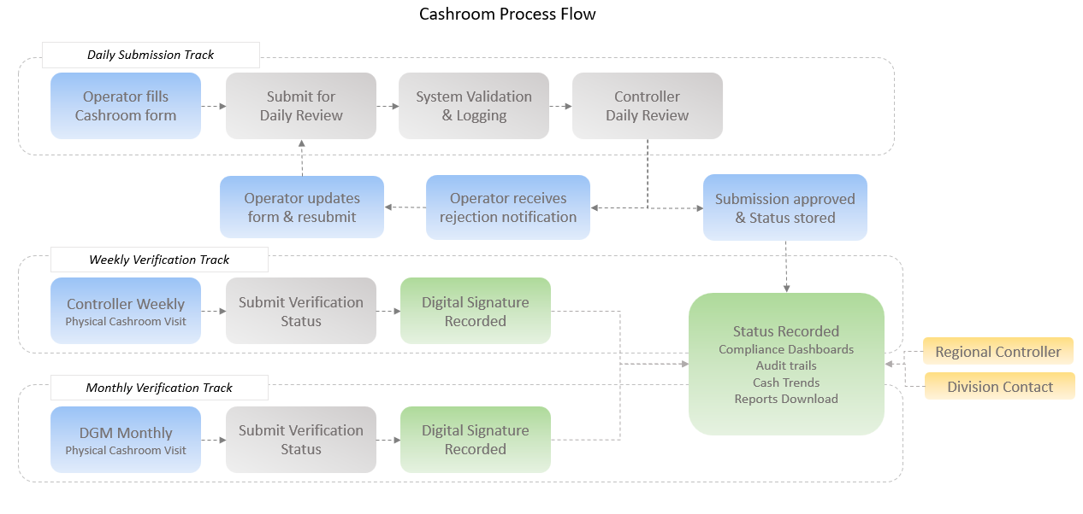

Non-Functional Requirements

Performance
- API response time < 5 seconds for standard operations
- Report generation < 40 seconds for weekly reports
- Support for concurrent usage by 100+ users

Scalability
- Auto-scaling serverless architecture to handle variable load
- Support for up to multiple locations
- Database design optimized for growth
- Horizontal scaling for all components

Availability and Reliability
- Target availability: 99% during business hours
- Automated retry mechanisms for transient failures
- Dead-letter queues for failed operations
- Multi-AZ deployment for critical services
- Idempotency controls to prevent duplicate submissions

Security
- Encryption in transit for all communications
- Encryption at rest using AWS KMS for all data stores
- Least-privilege IAM roles for all services
- Security headers and CORS policies
- Input validation and sanitization
- Optional AWS WAF for DDoS protection
- Secure handling of PII and sensitive data

Usability
- Intuitive conversational interface requiring minimal training
- Clear error messages and validation feedback
- Consistent user experience across all modules

Maintainability
- Well-documented code with inline comments
- Modular architecture for easy updates
- Infrastructure as Code (IaC) using AWS CloudFormation or Terraform
- Comprehensive logging for troubleshooting

Compliance
- Adherence to data retention policies (configurable, like 1- 7 years)
- Audit trail compliance with financial regulations
- GDPR and data privacy compliance for PII handling
- SOC 2 Type II aligned controls

Out of Scope for MVP
The following items are explicitly out of scope for the initial MVP delivery and may be considered for future phases:
- Voice calling channel integration (e.g., Amazon Connect)
- Chatbot for Cashroom form
- Directory federation and automated user provisioning (SAML/SCIM) unless required
- Advanced predictive analytics and ML-based risk assessment
- Mobile native applications (iOS/Android)
- Integration with existing ERP or financial systems
- Full parity recreation of every legacy Excel worksheet layout if an official output template is not mandated.

Assumptions, Client Dependencies & Pre-requisites

Project Assumptions
- Client will provide a complete master list of locations with assigned operators and approvers within 5 business days of project kickoff
- Tolerance policies (global and location-specific) will be finalized during Week 1
- Email infrastructure is available and operational for sending approval notifications
- Approver email addresses are valid and regularly monitored
- Data retention requirements will be confirmed as either 1, 3, 5, or 7 years based on audit policy
- Client will provide sample Cashroom verification data and expected outputs for validation
- No existing legacy system integration is required for MVP
- All users have access to modern web browsers (Chrome, Firefox, Safari, Edge)

Client Dependencies
- Timely provision of business requirements, field definitions, and calculation formulas
- Designation of a primary business stakeholder (Shivani) for decision-making and approvals
- Designation of IT architecture representative (Steve) for technical reviews
- Availability of 3-5 end users for UAT participation during Week 4
- Timely feedback and sign-off on deliverables within 2 business days
- Decision on environment strategy (dev, test, UAT, production)
- Confirmation of data residency and compliance requirements

Risk Management Approach
The following risks have been identified along with mitigation strategies to ensure successful project delivery:
Risk | Impact | Probability | Mitigation Strategy
Requirement finalization | High | Medium | Early requirement workshops in Week 1; frozen requirements by Day 5
AWS service quotas or limits | Medium | Low | Pre-verify quotas; request increases proactively
Email deliverability issues | High | Medium | Complete SES domain verification early; implement SPF/DKIM; test with actual approver emails
User adoption resistance | High | Medium | User-friendly conversational UI; comprehensive training; early UAT involvement; quick-reference guides
Scope creep during development | High | High | Formal change control process; clearly defined MVP scope; Phase 2 backlog for additional features
Data migration complexity | Medium | Low | Start fresh with clean data; historical data import is Phase 2 if needed
Security vulnerabilities | Critical | Low | Security review checklist in Week 3; AWS security best practices; penetration testing before go-live
Resource availability | Medium | Low | Dedicated team allocation; backup resources identified; clear escalation path

Risk Monitoring and Reporting
- Weekly risk review meetings with stakeholders
- Risk register maintained and updated throughout project lifecycle
- Immediate escalation protocol for critical risks
- Contingency planning for high-impact risks

Tentative Timelines
The following timeline represents a realistic execution plan based on current understanding and will be refined jointly during project initiation.
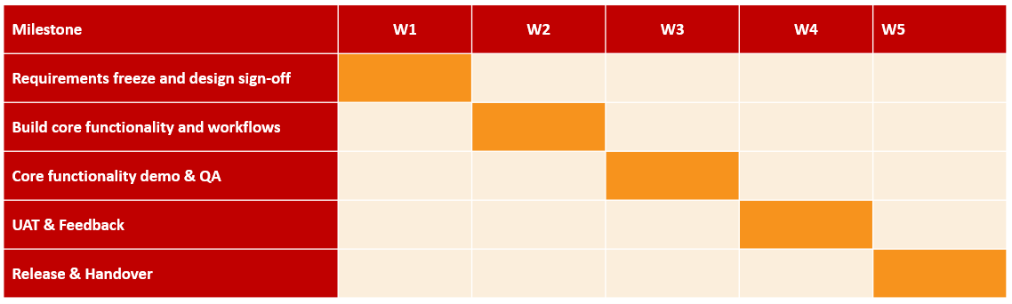

Week 1: Foundation and Design
Focus: Requirements finalization and technical foundation

Week 2: Core Development
Focus: Build core functionality and workflows

Week 3: Advanced Features and Hardening
Focus: Complete remaining features and quality assurance

Week 4-5: UAT and Go-Live
Focus: User acceptance testing and production deployment

Project Deliverables and Acceptance Criteria

Technical Deliverables
- Fully accessible functional Cashroom Compliance System deployed on AWS
- Deployment runbook and operational procedures

Documentation Deliverables
- User Guide, Training Materials and Quick Reference Cards
- Technical Documentation (system architecture, APIs)
- Troubleshooting Guide and FAQ
- Data Retention and Backup Procedures

Training Deliverables
- End-user training sessions
- Recorded training videos for future reference

Acceptance Criteria
The project will be considered complete when the following criteria are met:
- All functional requirements as specified are implemented and tested
- All non-functional requirements as specified are verified
- User Acceptance Testing (UAT) is successfully completed with sign-off from business stakeholders
- Security review checklist is completed with no critical vulnerabilities
- Performance benchmarks are met (response times, scalability)
- All documentation is delivered and approved
- Training sessions are conducted and recorded
- Production deployment is successful with post-deployment validation
- Go-live support period (5 business days) is completed
- Knowledge transfer to client IT team is completed

Support and Warranty

Go-Live Support
Damco will provide intensive support for 5 business days following production go-live, including:
- Dedicated support team available during business hours
- Rapid response to production issues (response time < 2 hours for critical issues)
- Bug fixes for any defects discovered during go-live period
- User support for questions and assistance
- Monitoring and proactive issue detection

Warranty Period
A 15-day warranty period will commence after successful go-live, covering:
- Bug fixes for defects in delivered functionality
- Corrections to documentation errors
- Performance issues related to code quality
- Resolution of issues identified during UAT but not yet fixed
Note: Warranty does not cover issues arising from changes to requirements, infrastructure modifications, or usage beyond specified capacity. New feature requests will be handled through a separate change request process.

Optional Ongoing Support
Post-warranty ongoing support and maintenance can be arranged through a separate agreement, including:
- Application monitoring and maintenance
- Bug fixes and minor enhancements
- AWS infrastructure optimization
- Monthly health checks and reporting
- Priority support with defined SLAs

Cost Estimates

Development Cost (Fixed Price MVP)
Based on the 30-day MVP scope with a dedicated team, the development cost breakdown is as follows:
# | Services | Cost (USD)
1 | MVP | $ 9,500
3 | 1 Weeks Hyper Care Support | $ 0
 | Total | $ 9,500

Payment Terms
Proposed payment schedule:
# | Milestones | Distribution
1 | Contract Sign-off | 30%
2 | Baseline Achievement & completion of Week 2 milestone (core functionality demo) | 40%
4 | UAT sign-off | 20%
5 | Successful production go-live | 10%

Notes:
- This cost is exclusive of any taxes or duties, if applicable at any time
- *This cost is just for solution implementation, SOW with additional cost for infrastructure will be shared separately
- All resources will be operating remotely from India
- Any travel or other work-related expense will be pre-approved and billed to Client on actuals
- Offshore resources will work from 10:30 AM IST (Indian Standard Time) to 7:00 PM IST (unless otherwise specified and agreed upon in writing)

Invoicing
- Damco shall raise invoices in accordance with the payment milestones defined in the Payment Milestones section of this Statement of Work.
- All invoices shall be issued in United States Dollars (USD) and are payable within fifteen (15) calendar days from the invoice date, unless otherwise agreed in writing.
- Payments shall be made via wire transfer or check payable to Damco Solutions Inc., as per the banking details specified on the invoice.
- All fees quoted under this Statement of Work are exclusive of applicable taxes, duties, or governmental levies. Any such taxes, if applicable, shall be borne by the Client in accordance with prevailing laws and regulations.

Contact Information
Contact personnel for this Statement of Work shall be as follows (subject to change):
# | Party | Name | Designation | Contact
1. | Compass Groups | Shivani Gupta | Finance - VP | Shivani.Gupta@compass-usa.com
2. | Damco | Manish Gupta | Technology - VP | manishg4@Damcogroup.com

Terms and Conditions

Change Management
Any changes to the scope, requirements, or deliverables after project commencement will follow a formal change control process:
- Change requests must be submitted in writing
- Impact assessment will be provided within 2 business days
- Changes may affect timeline and cost
- Approved changes will be documented with revised estimates
- Client authorization required before implementing scope changes

Confidentiality & Ownership
- Damco acknowledges and agrees that all information concerning Client Application and data is “Confidential and Proprietary Information”. Damco undertakes that it will not permit the duplication and disclosure of any such Confidential and Proprietary information, pertaining to Client, to any person other than to personnel who require such information for the performance of their obligations covered by this SOW
- Client acknowledges and agrees that all information concerning Damco’s business is “Confidential and Proprietary Information”. Client undertakes that it will not permit the duplication and disclosure of any such Confidential and Proprietary information, pertaining to Damco, to any person other than to personnel who require such information for the performance of their obligations covered by this SOW
- Damco's total aggregate liability in contract, tort (including negligence and breach of statutory duty howsoever arising), misrepresentation (whether innocent or negligent), restitution or otherwise, arising in connection with the performance or contemplated performance of the services under this SOW or any collateral contract thereto shall be limited to the total amount of charges paid by the Client and received by the Damco under this SOW.

Acceptance & Signoff
IN WITNESS WHEREOF, the parties have caused this Statement of work (SOW) to be executed by their duly authorized representatives as of the date written below:
Damco Solutions Inc. |  |  | Compass Group
Signature: |  |  | Signature:
Name: |  |  | Name: | Shivani Gupta
Title: |  |  | Title: | Finance, VP
Date: |  |  | Date:

